# Customer Relationship Management

## Main Listing Page:

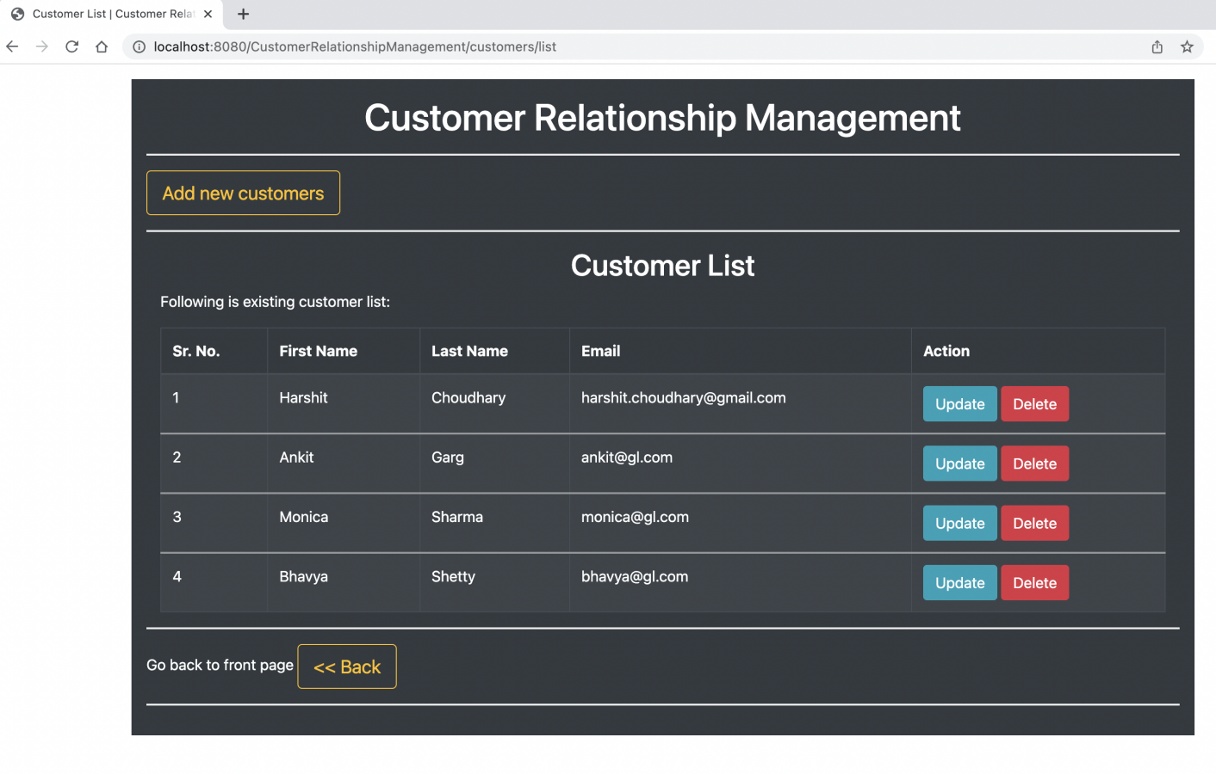

## Customer Registration/ Add new customer form:

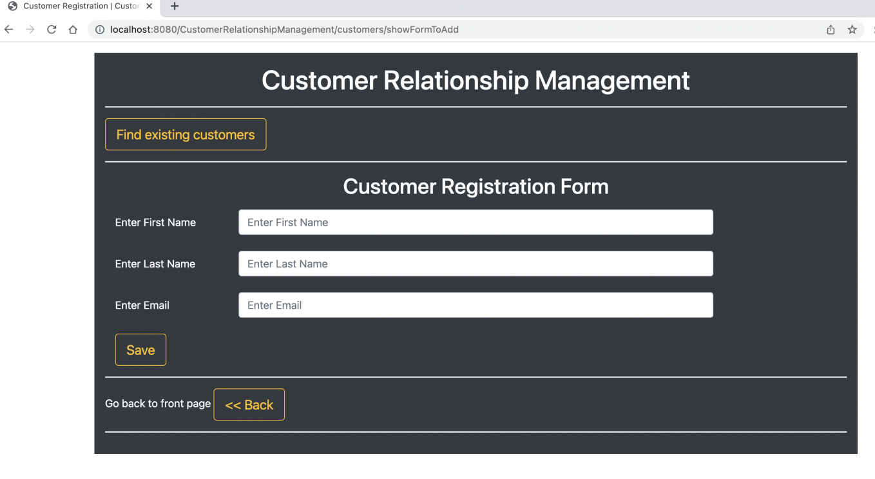

## Added values to Customer Registration form:

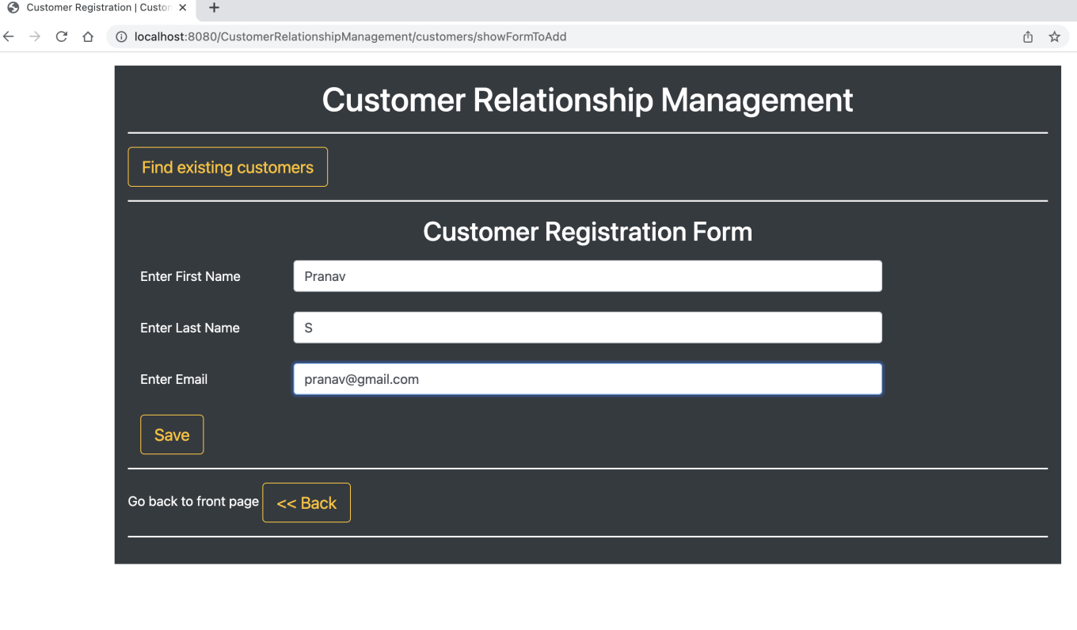

## New Customer ‘Pranav’ updated to list: Screenshot 2022-10-01 at 6.50.52 PM

## 3. Click to update Customer ‘Harshit’: Screenshot 2022-10-01 at 6.51.41 PM

## 3.1.Change email of ‘Harshit’: Screenshot 2022-10-01 at 6.52.14 PM

## 3.2 . Updated list with revised email: Screenshot 2022-10-01 at 6.52.35 PM

## 4. Delete Customer ‘Harshit’:

## Screenshot 2022-10-01 at 6.53.24 PM

## 4.1. Updated list after deletion of Customer ‘Harshit’:

## Screenshot 2022-10-01 at 6.53.45 PM